|  |  |
| --- | --- |
| http://eluntas.untag-smd.ac.id/pluginfile.php/16622/mod_resource/content/1/LOGO_RESMI_UNTAG.JPG | **RENCANA OPERASIONAL**  **FAKULTAS EKONOMI**  **2013-2017** |

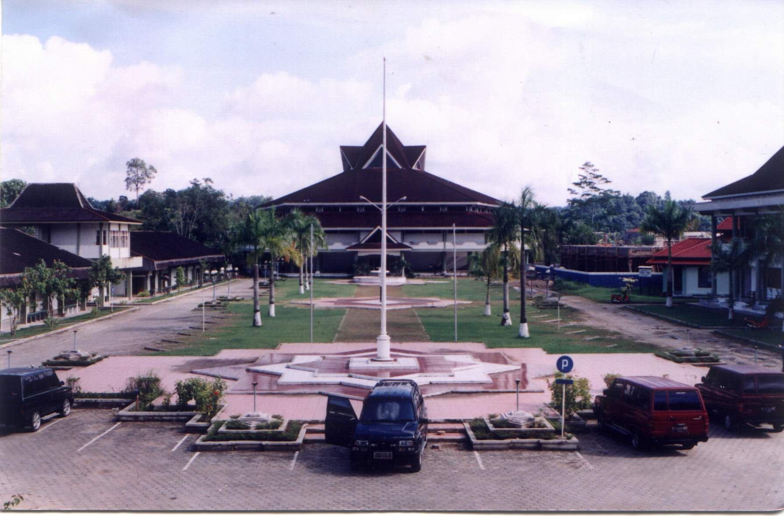

### **UNIVERSITAS 17 AGUSTUS 1945 SAMARINDA**